My testing for both the Contact Service and the Task Service was directly aligned with the software requirements that were provided. I started by turning each requirement given into a set of test scenarios that included valid inputs that should succeed, invalid inputs that should be rejected, and operational behaviors like add, update, and delete that must change the stored data correctly. For example, 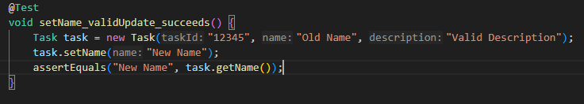
setName_validUpdate_succeeds is a test that tests the setter operation for the variable name. It shows an example of a valid name for the name variable. An example of testing invalid inputs is, 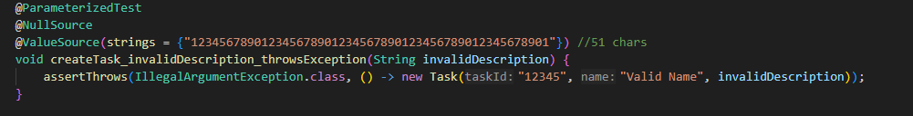
createTask_invalidDescription_throwsException is a test that tests the creation of a variable description which as stated in the rules cannot be larger than 50 characters or null. This creation fails and the test throws an error message. An example of the operational behavior add is, 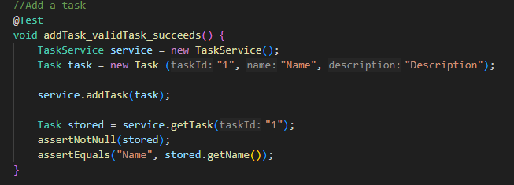
addTask_validTask_succeeds is a test that tests adding a task to the hash map. This test follows the requirements and will succeed. All of these tests are directly related to one of the requirements that were provided.
Though I did not use a coverage tool on my assignments, I can confirm that the coverage was very high. For each service, the tests execute every public operation the service provides and verifys the expected results using assertions. For example, I did not only test that a task could be created, I also tested that it could not be created when constraints are violated.
I ensured my code was technically sound by using clear, objective assertions and by explicitly testing failure behavior. After running the operational behaviors like addContact(), I retrieved the stored object and verified it was not null and contained expected values using assertions. 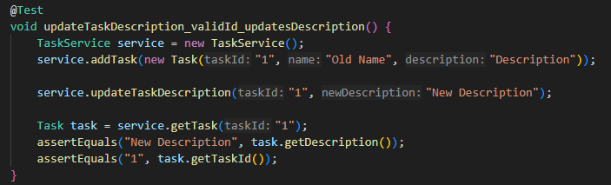
I also verified error handling by asserting that invalid actions would throw the correct exception using
Code efficiency was improved using parameterized tests, which allow the same test logic to be executed with multiple input values. This reduced redundancy in the tests by eliminating the need to write separate test methods for each input variation. 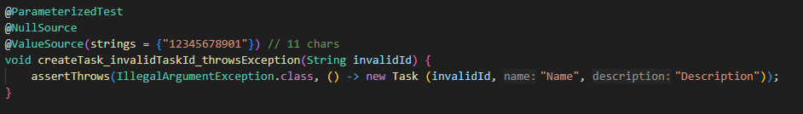
createTask_invalidTaskId_throwsException is a parameterized test that tests two input values null and “12345678901” in one test.
For the contact service, task service, and appointment service milestones, the primary software testing technique used was unit testing using JUnit 5. Unit testing focuses on verifying individual classes and methods in isolation to ensure they meet their functional requirements. A few examples of what the unit tests validated in these milestones are object creation, field constraints like null checks and length limits, and adding and deleting records. Parameterized tests were used wherever possible as they helped reduce redundancy in the code.
There are several other testing techniques that were not used in these milestones that are used very often in other projects. Integration testing was not necessary because the service did not interact with each other or with other systems like a database. There was no user interface included in these milestones, so system testing and user acceptance testing were also not used. There was also no performance or stress testing done because it was a small project that will never handle high loads.
The testing techniques that were mentioned have different practical uses depending on the type of software project. Unit testing, which was the main testing used in these milestones, is most effective in modular and object-oriented systems because it helps find defects in the system early. Integration testing becomes essential in larger systems where there are multiple systems interacting with each other. System testing is critical for user interfaces. Performance testing is used when a system is expected to handle high loads of traffic
Throughout this project, my mindset consisted of being cautious and detail oriented while acting as a software tester. I approached each assignment, the Contact, Task, and Appointment files with the understanding that even small validation errors could lead to incorrect application behavior. Because these services manage stored data, I carefully tested both successful and failure paths. For example, I did not only verify that objects could be created successfully, but I also created tests that intentionally violated constraints such as null values and excessive filed lengths to confirm that exceptions were properly thrown. This cautious approach was important because edge cases are a high-risk area in most programs. Appreciating the interrelationships of the code ensured that updates, deletions, and validations all worked together correctly and did not introduce hidden defects.
While reviewing my code I made a great effort to limit the bias I had towards my own code. While testing your own code, its easy to create confirmation bias, where the developer writes tests that prove their code works instead of writing tests that try to break it. To counter this, I designed tests from the perspective of a hostile user by including invalid inputs, duplicate IDs, and boundary value violations to ensure proper error handling. By testing both positive and negative scenarios, I reduced the risk of overlooking defects that might appear in real world use.
Finally, I remained disciplined in my commitment to software quality. Avoiding shortcuts in testing helps prevent technical debt and improves long term maintainability. I supported this by writing clear assertions and using parameterized tests to reduce redundancy while maintaining strong coverage. Well, designed automated tests improve software reliability and support sustainable development practices (Yulanda et al., 2025). Moving forward, I plan to continue emphasizing through unit testing and edge case validation to maintain high code quality. h

References
Yulanda, R. A., et al. (2025). Refactoring for sustainable maintainability: A SonarQube-based case study on a campus canteen application. In 2025 8th International Conference on Informatics and Computational Sciences (ICICoS) (pp. 143–148). IEEE. https://doi.org/10.1109/ICICoS68590.2025.11329637

